


Korea Lunar Exploration Program
DTNPL Thermal Analysis Report

Date: 28 Dec. 2017 | Doc. No: KPLO-D0-550-104  Issue: 1.0  Total page: 17

Superseding Revised

Prepared By:  Jeong-Chan Lee Date  DTN SBC Mechanical Engineer, Lumir  Dae-Soo Oh Date  DTN SBC Engineer, Lumir |  | Kyung-Rak Lee Date  DTN Payload Engineer, ETRI
Reviewed By:  Jin-Ho Jo Date  DTN System Engineer, ETRI |  | Sin-Ae Ji Date  Proximity-1 System Engineer, ETRI
Sang-Man Moon Date  RLE KPLO Electrical System, KARI |  | Hyun-Jin Shin Date  RLE KPLO Mechanical System, KARI
Approval Signature:  Byoung-Sun Lee Date  DTN Project Leader, ETRI |  | Il-Young Kim Date  RLE KPLO Product Assurance, KARI
Seong-Bin Lim Date  Head, Lunar Exploration System Team, KARI |  | Seok-Weon Choi Date  Director, Lunar Exploration Program Office, KARI

Original CDMO Release__________________

Revision History
Version | Author(s) |  | Date | Description
0.1 | Jeong-Chan Lee |  | 2017. 12. 28 | Draft

Revision/Change Records
Version | Date | Revision/Change Description | Pages
0.1 | 2017. 12. 28 | Initial | All

Documents Tree

Contents

1. Introduction 8
1.1. Purpose and Scope 8
1.2. Applicable Documents 8
1.2.1. ETRI Documents 8
1.2.2. Other Documents 8
1.3. Abbreviations 8
2. Operation Description 9
2.1. DTN and Space Communications 9
2.2. Mission of DTN Operation 9
2.3. DTN Configurations 9
2.4. Communication Nodes 10
2.4.1. DTN nodes 10
2.4.2. Non-DTN nodes 10
3. Thermal Analysis of DTN Payload 11
3.1. Thermal analysis purposes and model definition 11
3.2. Analysis Conditions 11
3.2.1. Information Analysis 11
3.2.2. Material property 12
3.2.3. Contact condition 12
3.3. Result of Analysis 13
3.3.1. All Body 13
3.3.2. PCB thermal analysis result 15
3.4. Review results 16

Figures

Figure 2.1 DTN test configuration in the first phase 10
Figure 2 Thernal Analysis Target Model Configuration 11
Figure 3 FEM Model for Target Model 12
Figure 4 Temperature Distribution Contour for All Body (Housing) 13
Figure 5 Temperature Distribution Contour for All Body (Board) 13
Figure 6 PCB Calorific value information (Top) 14
Figure 7 PCB Calorific value information (Bottom) 14
Figure 8 Thermal analysis results for the PCB (Top) 15
Figure 9 Thermal analysis results for the PCB(Bottom) 15

Tables
Table 1 Material property 12
Table 2 Contaco Conditions 12
Table 3 PCB Thermal analysis result 16

Introduction

Purpose and Scope
This document describes the Thermal Analysis of DTN payload for Korea lunar exploration program.

Applicable Documents

ETRI Documents
Document Number | Document Title
KPLO-D0-551-002 | Operation Scenario of DTN
KPLO-D0-550-000 | System Requirements of DTN Payload

Other Documents
Document Number | Document Title
KPLO-SP-300-002 | KPLO System Requirements Document

Abbreviations
AMS | Asynchronous Message Service
AOS | Advanced Orbiting System
BP | Bundle Protocol
BSS | Bundle Streaming Service
CCSDS | Consultative Committee for Space Data Systems
CFDP | CCSDS File Delivery Protocol
DCC | DTN Control Center
DTN | Delay(Disruption) Tolerant Network
DTNPL | DTN Payload
IP | Internet Protocol
KPLO | Korea Pathfinder Lunar Orbiter
M&C | Monitor & Control
ISTS | Integrated Satellite Test Software
TBC | To Be Confirmed
TBD | To Be Defined
TCP | Transmission Control Protocol

Operation Description

DTN and Space Communications
Delay/disruption tolerant networking (DTN) technology offers a new solution to highly stressed communications in space environments, especially those with long link delay and frequent link disruptions in deep space missions. Delay/disruption tolerant networking (DTN) technology offers a new solution that use a store-and-forward mechanism to combat long link delay and frequent link disruptions generally characterizing space communications. DTN communications use a bundle protocol (BP), to construct a store-and-forward overlay network. The BP, situated at the application layer of the Internet model, utilizes conventional Internet protocols to send and receive data bundles. The benefits of DTN communications are as follows.
- Interoperability and Reuse: A standardized DTN protocol suite enables interoperability of multi-agency communication assets and also allows NASA to use the same communication stack for future missions (LEO, NEO or Deep Space).
- Space Link Efficiency, Utilization and Robustness: DTN enables more reliable and efficient data transmissions resulting in more usable bandwidth. DTN also improves link reliability by having multiple network paths and assets for potential communication hops.
- Security: The DTN Bundle Security Protocol (BSP) allows for integrity checks, authentication and encryption, even on links where not previously used.
- Quality of Service: The DTN protocol suite allows for many priority levels to be set for different data types, ensuring that the most important data is received ahead of less important data.
- Improved Operations and Situational Awareness: The DTN store-and-forward mechanism along with automatic retransmission provides more insight into events during communication outages and significantly reduces the need for ground-based scheduling.

Mission of DTN Operation
The mission of DTN is to validate DTN communication protocols by space link testing through KPLO. So DTN operations are focused on testing the DTN protocols using KPLO space links.

DTN Configurations
In the first phase of lunar exploration, test lunar orbiter called Korea Pathfinder Lunar Orbiter (KPLO) will be launched without lunar lander. Figure 2.1 shows DTN configuration in first phase of lunar exploration. There are no Lander and Rover on the moon in first phase. So Lander Communication Mode (LCM) and Rover Communication Mode (RCM) will be located on earth for the DTN communication testing.
DTN Payload (DTNPL) is a DTN node in the space. DTNPL will be mounted on the KPLO for DTN communication. DTN Control Center (DCC) is a control center of DTN communication nodes. LCM and RCM are DTN nodes on ground. All DTN nodes on ground are interconnected by the terrestrial network such as Internet. MCC and DSN are not DTN nodes. They just transfer DTN packets to next communication nodes.

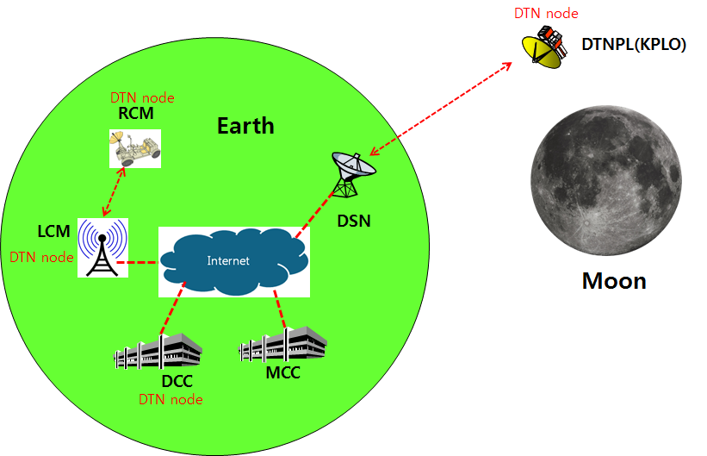
Figure 2.1 DTN test configuration in the first phase

Communication Nodes
Many communication nodes are needed for the DTN operation. Some of communication nodes in the network are DTN nodes whereas otherwise nodes are non-DTN nodes. The function of communication nodes used in the DTN operation is as follows.

DTN nodes
- DCC is a ground DTN node which monitor and controls DTN nodes. DCC send commands to DTN nodes such as DTNPL, LCM and RCM. It also receives telemetries or acquired data from some DTN nodes such as RCM or LCM.
- DTNPL is a DTN node mounted on the KPLO. DTNPL can be operated as a DTN end point. And it also can be operated as relay nodes which relay DTN data between DCC and RCM or LCM.
- LCM is a ground DTN node. LCM relays DTN data between MCC and RCM.
- RCM is a ground DTN node and a DTN end point. The commands sent by the DCC is terminated at the RCM and the RCM returns telemetry or data to DCC through KPLO.

Non-DTN nodes
- MCC is a non-DTN node. MCC monitors and controls KPLO and payloads. MCC also receives and processes data generated from the payloads and transfers to each payload control center.
- DSN is a ground station for deep space communication. DSN will have a big size of antenna and RF equipment for space link interface. DSN also have network equipment for terrestrial communication interface such as SLE link. DSN is a non-DTN node.

Thermal Analysis of DTN Payload

Thermal analysis purposes and model definition
Research on thermal analysis was conducted to determine the operating temperature and design verification of DTN Payload analysis model for it is shown in the following figure.

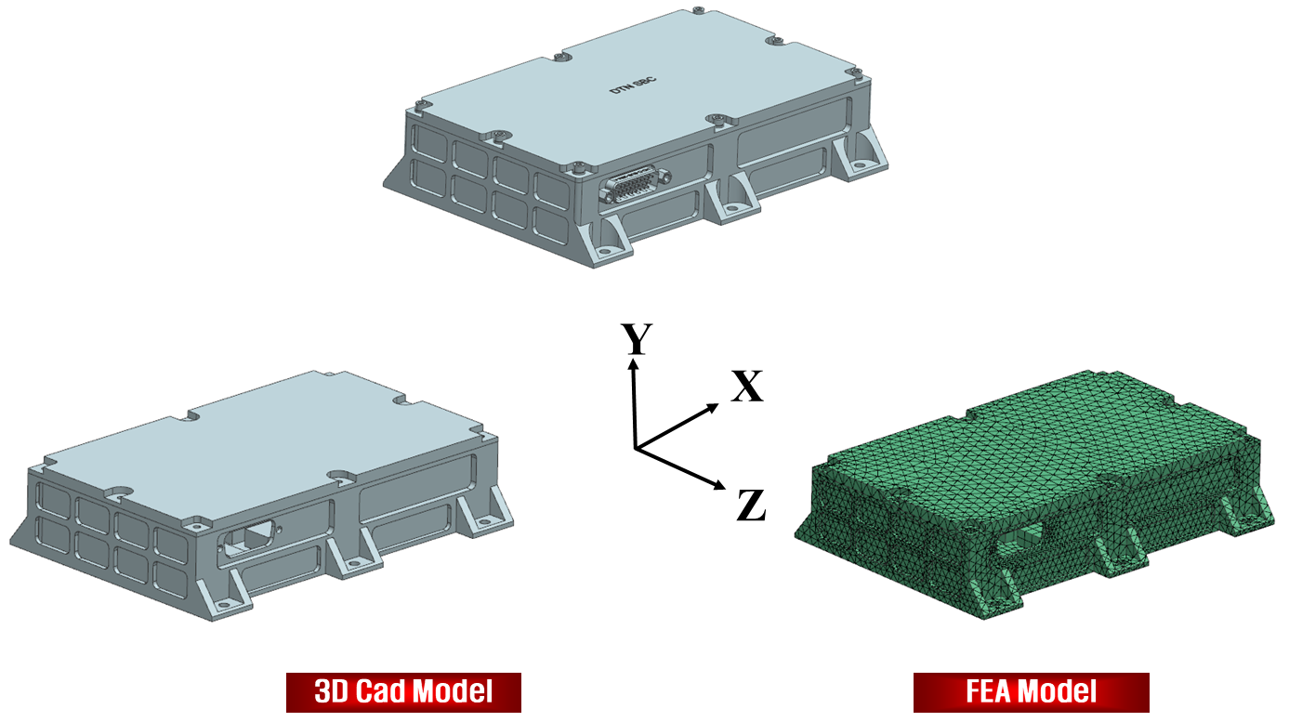
Figure 2 Thernal Analysis Target Model Configuration

Analysis Conditions

Information Analysis

FEA Modeling
Through the model information in Figure 2, the 3D CAD model was subjected to the mesh generation with the thermal analysis FEA model. Information about the FEA model is as follows.
- FEA Solver: NX Space Systems Thermal V 10.0
- AL Structure (Housing, Cover) Modeling: Using the 3D Tetrahedron Element to Configure the FEA Model
- PCB Modeling: PCB modeling with Shell Element
- EEE parts 모델링
- IC chip uses Hexa element to construct FEA model
- Number of node : 78,898 EA

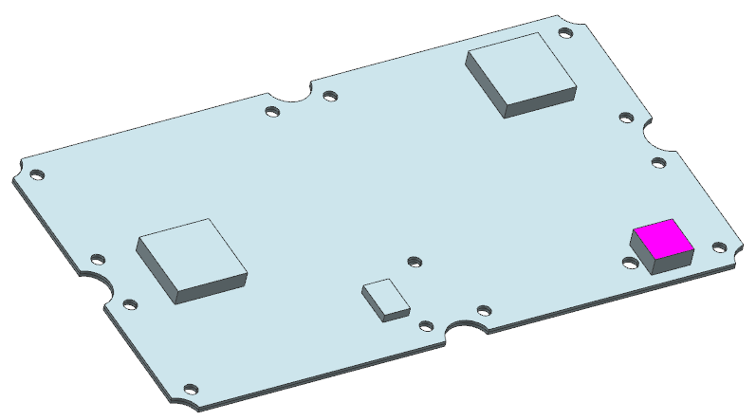
Figure 3 FEM Model for Target Model

Steady state analysis
- Base plate temperature : 50 ℃
- Consider thermal conduction only.
- The calorific value is calculated as the total calorific value for the entire volume.
- Consider contact thermal resistance and other thermal analysis conditions

Contact heat conduction
- In order to accurately model the actual phenomenon, contact thermal conductivity is applied
- If material properties such as heat conductivity and specific heat of individual parts are not known, uniform value application
- Refer to the reference thermal conductivity coefficient
- The contact thermal conductivity coefficient is very large due to surface roughness, contact pressure,

Material property
The material properties for thermal analysis are shown in the following table..

Table 1 Material property
 | Density (kg/m³) | Conductivity (W/m•K) | Specific Heat (J/kg•K)
AI6061-T6 | 2,700 | 156 | 900
PCB | 1,850 | 49 | 840
EEE Parts | 2,330 | 149 | 794

Contact condition
The contact conditions of the materials are shown in the following table.

Table 2 Contaco Conditions
 | Contact Conductance (W/m²•K) | Reference
AI - AI | 250 | “Heat Transfer”, A. F. Mills  (Moderate Pressure, usual finishes)
AI – PCB | 250 | “Heat Transfer”, A. F. Mills  (Moderate Pressure, usual finishes)
EEE – PCB | 5,262 | “Heat Transfer”, A. F. Mills  (Moderate Pressure, usual finishes)  Space Craft Thermal Control Handbook Vol. 1

Result of Analysis

All Body
The thermal analysis results for the entire structure are shown in the following figure.

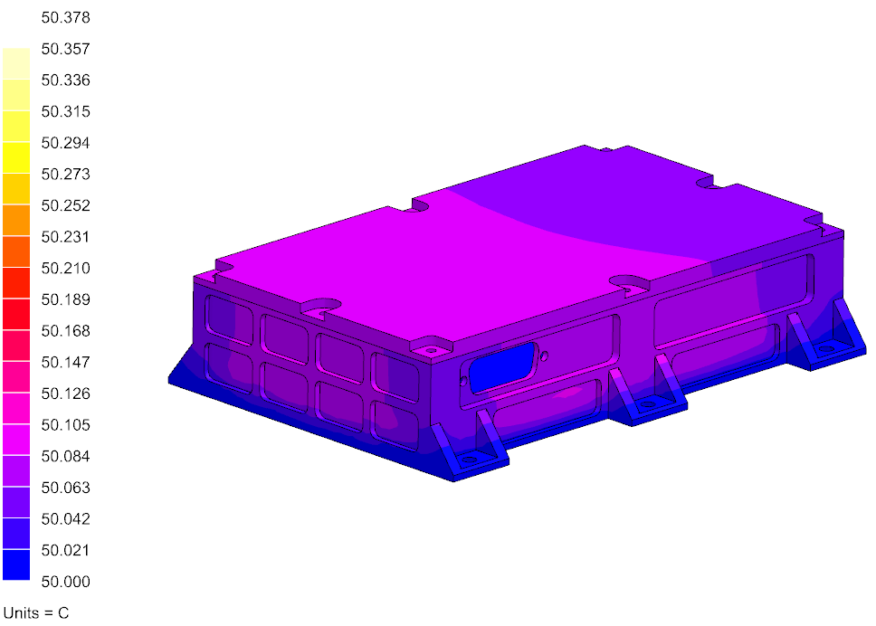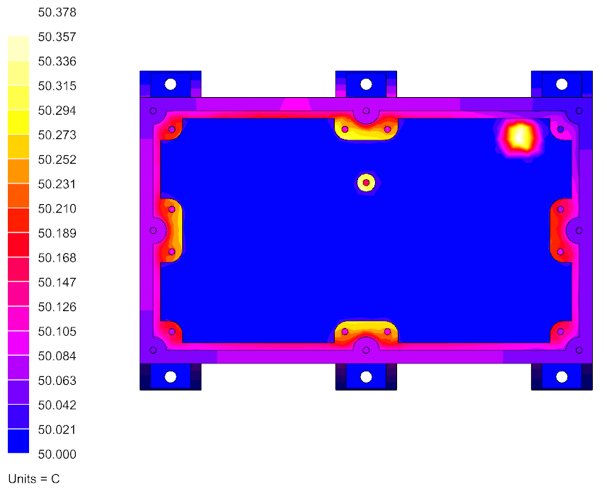
Figure 4 Temperature Distribution Contour for All Body (Housing)

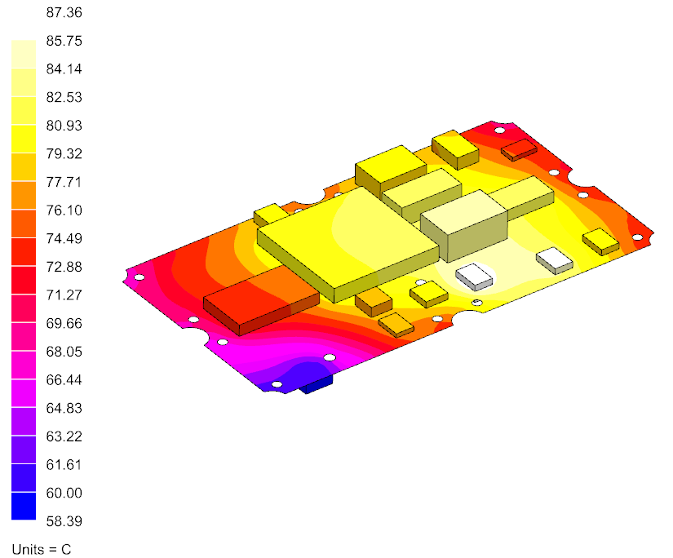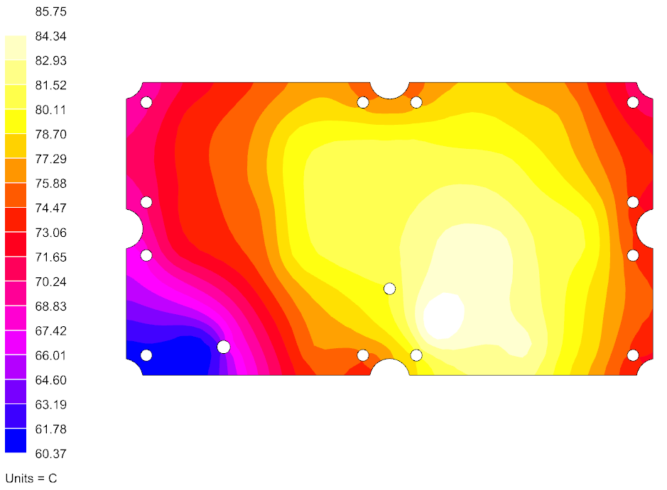
Figure 5 Temperature Distribution Contour for All Body (Board)

The calorific value information for the PCB is shown in the following figure.

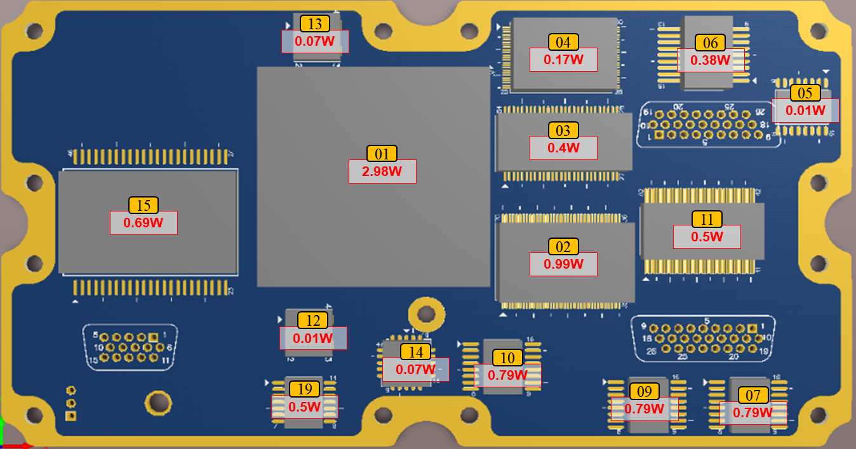
Figure 6 PCB Calorific value information (Top)

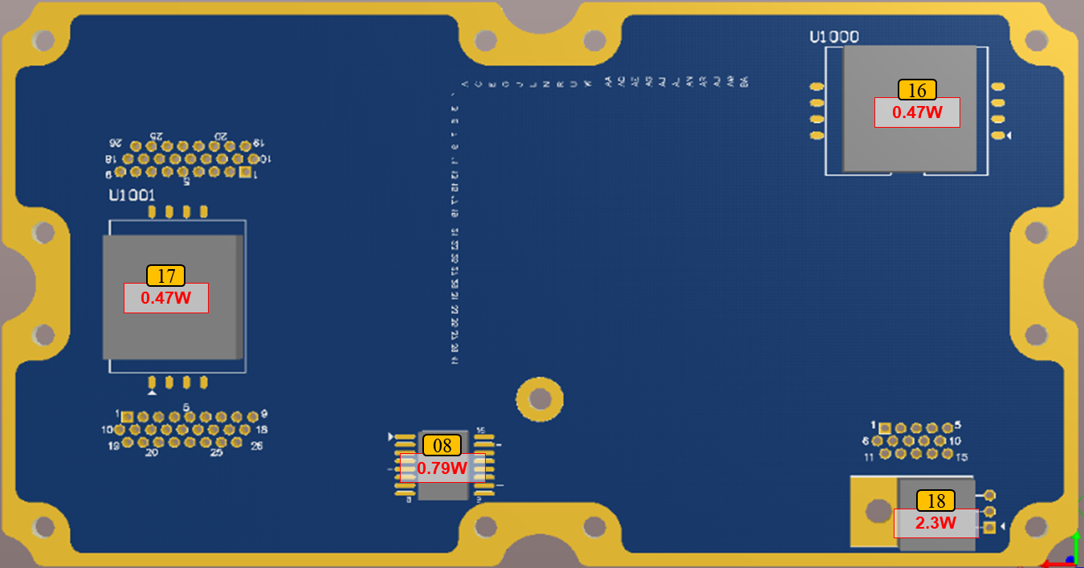
Figure 7 PCB Calorific value information (Bottom)

PCB thermal analysis result
Thermal analysis results for the PCB are shown in the following figure.
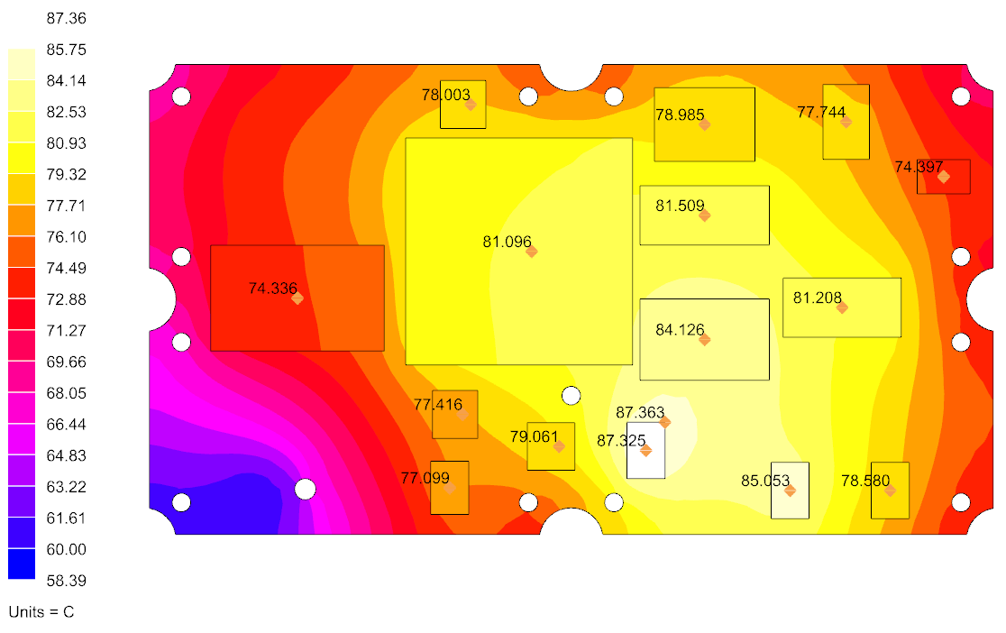
Figure 8 Thermal analysis results for the PCB (Top)

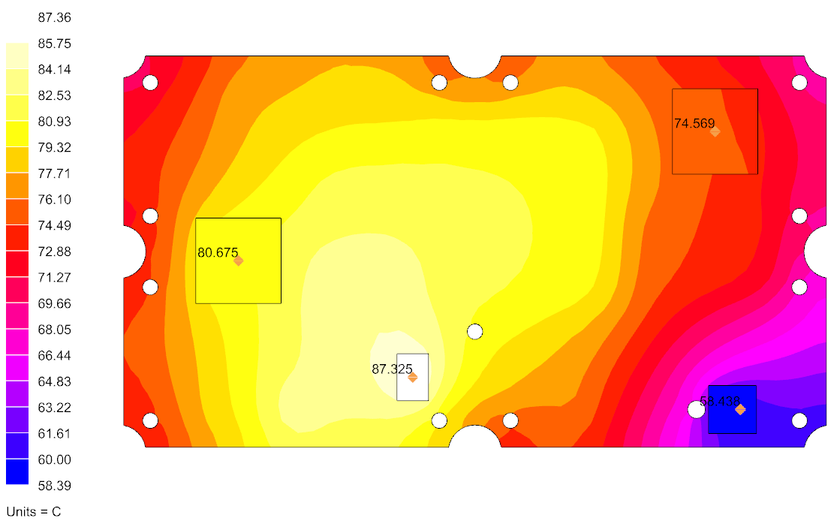
Figure 9 Thermal analysis results for the PCB(Bottom)

Table 3 PCB Thermal analysis result
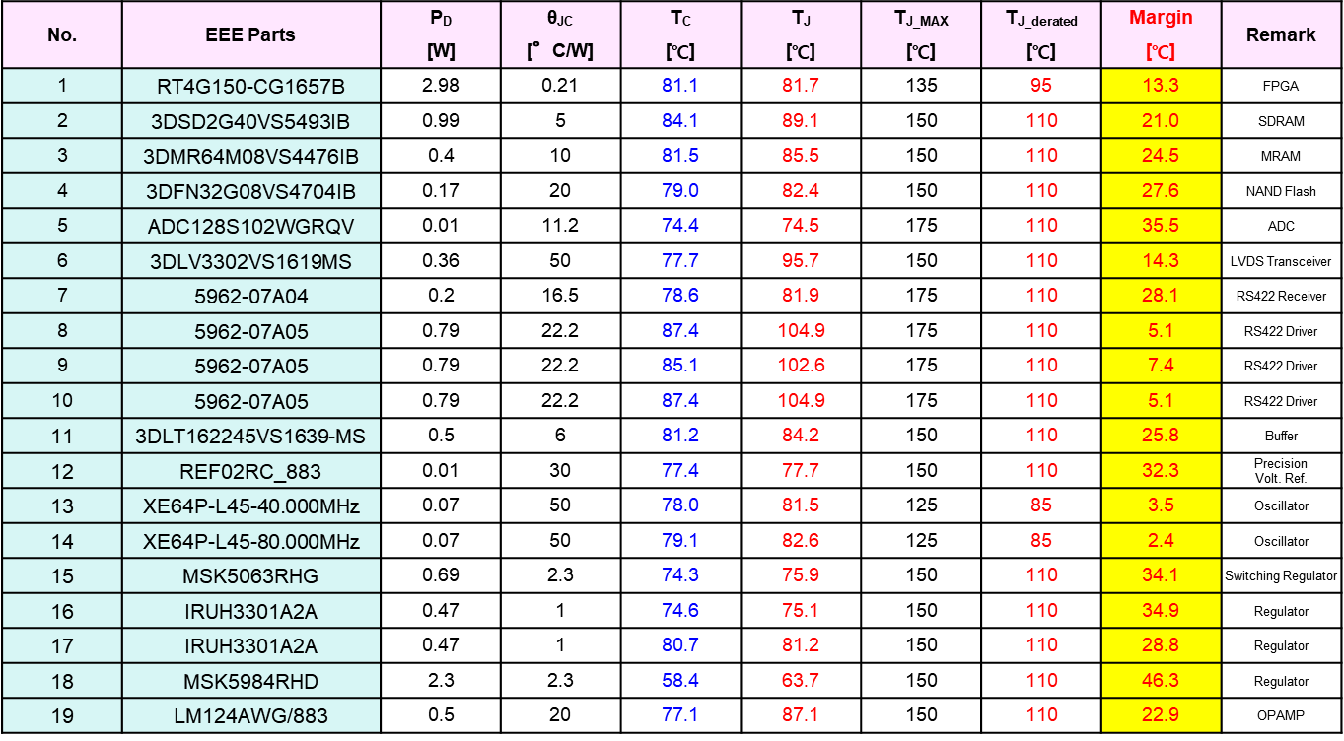
T_{J_derated} applies ECSS-Q-60-11.

Review results
The thermal analysis results show that all components have a margin of at least 2.4 ° C based on the derating temperature and the maximum PCB temperature is around 87.4 ° C through Figure 8. There is no particular limitation on the thermal analysis. However, when the physical properties such as the heat conduction coefficient and specific heat of the individual components are not secured, a uniform value may be applied and there may be a difference from the actual results.

